3AWS PROJECT SESSIONS
Project Write-Up

01 | Project Overview

Project name | Project type
Holiday Photo Website | Serverless website
Prepared by | Date
Stuart Allan | May 2026

One-line project summary
Produce a static website that showcases holiday photos from the last 7 years

02 | Problem Statement

Who is this for?
Family to showcase a selection of holiday photos

What problem exists today?
The customer currently has no way of easily showing holiday photos to friends and family. An online website will allow this process to occur easily.

What does success look like?
A website that shows photos from a selection of holidays detailing where and when the holiday took place, where the photo was taken, and a short description of what the photo shows.

03 | Proposed Solution

Solution overview
A static website where the home page lists the holiday destinations that are clickable links.
Each clickable link goes to another web page that shows small versions of the photos, each of which is also a clickable link taking you to yet another web page that shows the photo full size alongside a description of the photo.

Why cloud? Why AWS?
Cloud based is the correct solution as there is no costs involved other than buying the website domain name itself.

Key features delivered
Select the holiday you want to view the photos of.
Select the individual photo to see it larger alongside a description.

04 | Architecture Diagram

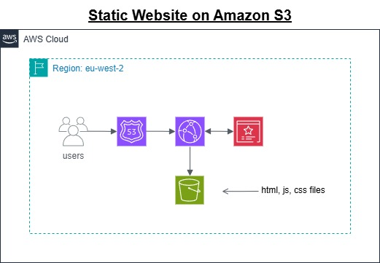

05 | AWS Services Used

Service | What it does in this project
STORAGE
S3 | Hosts the static webpage
NETWORKING & DELIVERY
CloudFront | Server content from edge locations
Route 53 | Translates the domain to the CloudFront distribution
SECURITY & IAM
Certificate Manager | Provides a security certificate

06 | Application Flow

Flow 1 — [Name your first flow, e.g. Visitor loads the website]
- Step 1: Visitor types the domain name into their browser
- Step 2: Route 53 translates the domain to the CloudFront distribution
- Step 3: CloudFront checks its cache — serves from edge if cached
- Step 4: If not cached, CloudFront fetches from S3 via Origin Access Control
- Step 5: Browser loads the page

07 | Security

Security control | How it is implemented in this project | Status
HTTPS / TLS encryption | CloudFront redirects HTTP to HTTPS.  All traffic encrypted in transit via TLS. | Implemented
Private S3 bucket | Block All Public Access enabled. Only CloudFront can access the bucket via Origin Access Control (OAC). | Implemented
SSL Certificate | Free ACM certificate issued in eu-west-2, auto-renewing, attached to CloudFront distribution. | Implemented

Known limitations / not implemented in this version
Rate limiting on the contact form API is not implemented in this version.
A production deployment would add AWS WAF rules to prevent spam.

08 | Cost Estimate

Service | Usage assumption | Free Tier cost/month | Production cost/month
S3 | 40 page views/month | £0.00 | £0.00
CloudFront | 50 https requests/month | £0.00 | £0.00
Route 53 | .com domain + Route 53 hosted zone | N/A | ~£1.00/month
Certificate Manager | 1 certificate | £0.00 | £0.00
ESTIMATED MONTHLY TOTAL |  | £0.00 | £1.00/month

09 | Next Steps & Future Improvements

Planned improvements for the next version
Add a contact form for visitors to get in touch

GitHub repository link | Live project URL
https://github.com/stuartallan1981/allanfamilyholidayphotos | https://www.allanfamilyholidaywebsite.com

